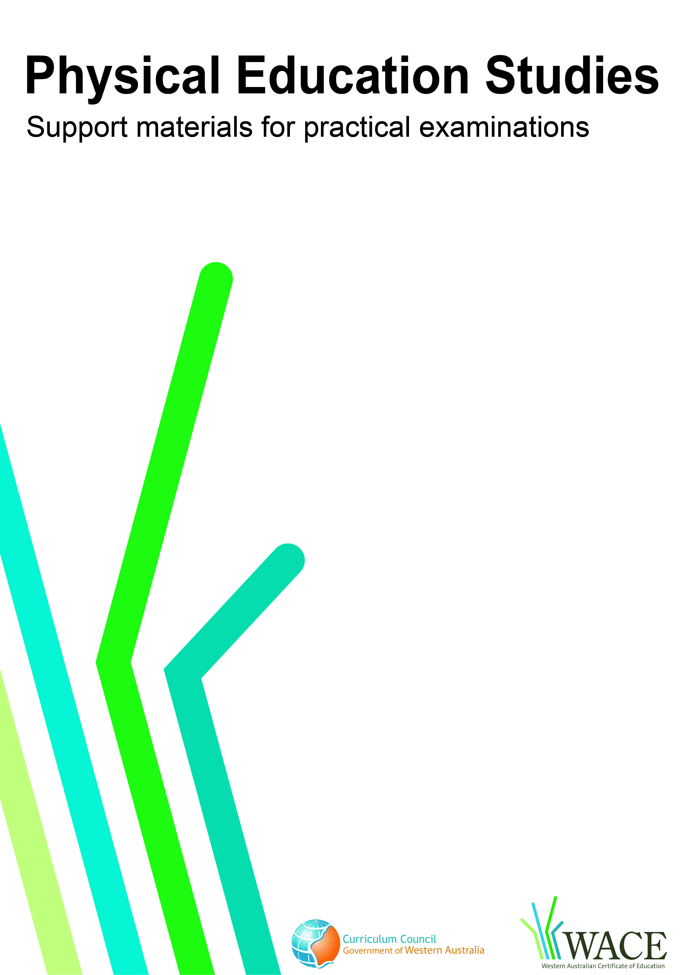

Volleyball
Volleyball
Updated July 15 by Reid and Joanne T
To be trimmed.

© Curriculum Council, 2011
This document—apart from any third party copyright material contained in it—may be freely copied, or communicated on an intranet, for non-commercial purposes by educational institutions, provided that it is not changed in any way and that the Curriculum Council is acknowledged as the copyright owner.
Copying or communication for any other purpose can be done only within the terms of the Copyright Act or by permission of the Curriculum Council.
Copying or communication of any third party copyright material contained in this document can be done only within the terms of the Copyright Act or by permission of the copyright owners.
Version 5

Introduction
Volleyball
The purpose of these materials is to support teachers and candidates in preparation for the Physical Education Studies practical examination.

Skills set for volleyball
These materials outline the examinable skills set for volleyball. Five (5) of the skills, selected by the examination panel, will be examined and these will be communicated to the candidates at the commencement of the examination.

Observation points
Observation points are provided for each skill in the skills set. They are provided for the purpose of teaching and coaching and are designed to assist examination candidates in their personal skill development.

Examination drills
The examination will contain a number of drills through which the selected skills will be assessed. These materials outline a number of drills indicative of the types of drills in which the candidates will participate during the examination and may form part of a teaching program.

Tactical framework
In the conditioned performance section of the examination, candidates will participate in a modified competitive situation, which will be based on some of the tactical problems in volleyball. The tactical problems for the examination are outlined in the tactical framework and will be selected by the examination panel. The skills that provide the basis for the solutions to these tactical problems are also included in the framework.

In the conditioned performance section of the volleyball examination, students will be assessed on the execution of skills, setting up an attack, court positioning and decision making that effectively solve the tactical problems presented by the modified competitive situation.

Specialist skills
Contained within this document are a number of skills that have been identified as having a degree of specialisation. They are skills that some students may choose to focus on. These skills are included within this document as they may form part of a teaching program; however, they will not be included in the Physical Education Studies practical examination.

CONTENTS | PAGE NUMBER
Volleyball skills set | 5
Skills set and observation points | 6
Volleyball drills | 10
Drill descriptions | 11
Tactical framework | 22

Skill number | Name of skill | Page number
1 | Overhead float serve | 6
2 | Jump serve | 6
3 | Combined jump-float serve | 6
4 | Forearm pass: free ball | 7
5 | Forearm pass: serve reception | 7
6 | Forearm pass: spike reception | 7
7 | Front set | 8
8 | Spike | 8
9 | Block | 8
10 | Specialist skill: back set  (not examined externally) | 9

1. OVERHEAD FLOAT SERVE
Preparation | Execution | Completion
- Server stands behind the baseline  - Straight arms point towards target with hitting hand behind the ball  - Weight on the back foot ready to be transferred onto front foot upon contact  - Step is towards the target with the opposite foot  - Hitting arm is drawn straight back behind the head with elbow flexion | - The ball is tossed up with the opposite hand in line with the serving hand, little spin and less than 1m high  - Opposite foot forward when contact is made with the ball  - Contact with the ball is above the head in line with the serving arm  - Contact with the ball is with an open hand | - Weight is transferred forward onto the court and move into a defensive position  - Arm follows through in the direction of the target; thumb brushing quadriceps on the same side as serving arm  - Ball has a flat trajectory and no spin(floating)  - Ball clears the net no higher than the top of the antennae
2. JUMP SERVE
Preparation | Execution | Completion
- Position behind the baseline at appropriate distance to allow approach routine  - Ball is tossed above the head with one or two hands in line with the serving hand  - Approach routine begins, including full jump with take-off from two feet (as per the spike approach)  - Hitting arm is drawn straight back behind the head with elbow flexion | - Ball is contacted above the head in line with the serving arm  - Ball is contacted with an open hand  - Wrist snaps to impart top spin | - Weight is transferred forward onto court and move is into a defensive position  - Arm follows through in the direction of the target with thumb brushing quadriceps on the same side as serving arm  - Ball has top spin and dips as it crosses the net  - Ball lands in last metre and a half of court
3. COMBINED JUMP-FLOAT SERVE
Preparation | Execution | Completion
- Position behind the baseline at appropriate distance to allow approach routine  - Approach routine begins, including full jump with take-off from two feet (as per the spike approach)  - The ball is tossed in front of the hitting shoulder and no higher than the antennae  - Hitting arm is drawn straight back behind the head with elbow flexion | - Ball is contacted with an open hand | - Weight is transferred forward onto the court and move is into a defensive position  - Arm follows through in the direction of the target; thumb brushing quadriceps on the same side as serving arm  - Ball has a flat trajectory and no spin(floating)  - Ball clears the net no higher than top of the antennae

4. FOREARM PASS: FREE BALL
Preparation | Execution | Completion
- Move is to get the ball in line with the midline of the body and to face the target  - Balanced position with weight on the balls of the feet and outside foot forward  - Shoulders directed towards the target with arms forming a stable triangle  - As ball approaches, position is lowered with greater knee bend | - Arms should be straight and in the midline with a flat platform  - Body weight is moving up and forward as is all of body movement  - Body goes from a low position to a high position in a forward flowing movement  - All contact is on the forearm (above ‘watch strap’) with elbows fully extended | - Arms follow through no higher than parallel to the court  - Ball travels on a parabola between the contact point and the setter
5. FOREARM PASS: SERVE RECEPTION
Preparation | Execution | Completion
- Move is to get the ball in line with the midline of the body and to face the target or execute lateral pass if receiving a jump serve  - Balanced position with weight on the balls of the feet and outside foot forward  - Shoulders are directed towards the target with arms forming a stable triangle  - As ball approaches position is lowered with greater knee bend | - Arms should be straight with a flat platform  - Body weight is moving up and forward as is all of body movement  - Body goes from a low position to a high position in a forward flowing movement  - All contact is on forearm (above ‘watch strap’) with elbows fully extended. Note: Jump serve is received with very little arm movement to cushion the ball on impact | - Arms follow through no higher than parallel to the court  - Ball travels on a parabola between the contact point and the setter  - Movement is into the team-attack position
6. FOREARM PASS: SPIKE RECEPTION
Preparation | Execution | Completion
- A balanced ready position is assumed to receive a spike  - Arms are relaxed  - Stance is wide and low  - Weight moves onto the balls of the feet with shoulders forward in readiness to move into position | - Contact is such that the arms almost ‘give’ on contact to take power out of the ball  - Contact is on forearms with elbows extended  - Arms ‘break’ at the elbows in the ‘J’ shape to control the impact of the ball | - Ball is controlled on own-side of the court to form an attack  - Ball is kept high, in the middle of the court and towards the attack line  - Movement is into the team-attack position

7. FRONT SET
Preparation | Execution | Completion
- Body is balanced with foot closest to the net slightly in front  - Knees and hips are flexed  - Hands are positioned slightly in front and above the head, forming a triangle  - Elbows are at 90⁰ with thumbs pointing to the floor | - Hips and shoulders are facing the target  - Base is stable and knees flex on contact  - Ball is cushioned with all fingers and thumbs of both hands  - Elbows flex upon contact followed by extension to 180° leading to release | - Arms point in direction of the target  - Thumbs and forefingers also point in the direction of the target  - Ball is released into a parabolic flight with no spin  - Next movement is into defensive position
8. SPIKE
Preparation | Execution | Completion
- Spike approach begins on or behind the attack line  - Spike approach footwork is R - L - together (opposite for left-hander)  - Knee bend is deep with arms swinging back parallel to the court  - Two-foot take-off is vertical and controlled  - Arms swing forwards and upwards to get maximum height in the jump  - Arms assume ‘bow and arrow’ position with hitting arm pulled back behind the body in a ‘bow’ position and non-hitting arm pointing to the ball | - Lead is with elbow first, then high contact with open hand on the ball, snapping the wrist on contact  - Contact is made at maximum height approx 50cm in front of the body and in line with the hitting shoulder | - Two-foot landing is controlled with flexion of knees to absorb impact  - Landing is in the same place as take-off  - Ball crosses the net in a downward path with speed  - Ball avoids the opposition block and spike-defensive players
9. BLOCK
Preparation | Execution | Completion
- Feet are shoulder-width apart and arm-length off the net  - Hands are in front of the body, at shoulder height and facing the opposition  - Fingers are spread  - Movement along the net is sideways and controlled | - Knees bend no more than 90º  - Knees are extended fully to jump vertically  - No gap is left between arms and net (maximum penetration)  - Arms are kept straight and strong reaching over the net  - Thumbs should be high, fingers spread and hands close together to avoid ball going through the middle of both hands | - Two-foot landing is controlled with flexion of the knees to absorb impact and without any net touches  - Ready position is resumed

10. SPECIALIST SKILL: BACK SET (not examined externally)
Preparation | Execution | Completion
- Body is balanced with foot closest to the net slightly in front  - Knees and hips are flexed  - Hands are positioned more above the head than in the front set  - Elbows are at 90⁰ with thumbs pointing to the floor | - Hips and shoulders are facing the target  - Base is stable and knees flex on contact  - Ball is cushioned with all fingers and thumbs of both hands  - Elbows flex upon contact followed by extension to 180° leading to release | - Arms point in direction of the target  - Thumbs and forefingers also point in direction of the target  - Ball is released into a parabolic flight with no spin  - Next movement is into a defensive position

Drill number |  | Page number
1 | Front set or forearm pass | 11
2 | Specialist skill: back set (not examined externally) | 12
3 | Forearm pass: free ball | 13
4 | Forearm pass: spike reception | 14
5 | Blocking | 15
6 | Serving – all types | 16
7 | Spiking | 17
8 | Forearm pass: serve reception, front setting or specialist skill: back setting, spiking | 18
9 | Forearm pass: free ball, front setting, spiking | 19
10 | Forearm pass, front setting, spiking | 20
11 | Forearm pass, spiking, blocking, front setting | 21

These drills are indicative of the types of drills in which the candidates will participate during the examination and may form part of a teaching program

Drill 1: Front setting or forearm pass

X₃
X₂
X₁

Key

X = player | → = player movement
O = feeder | ----- = ball movement
= marker

Drill description
- X₁ front sets the ball to X_{2.}
- X₂ front sets the ball back to X₁.
- Drill is repeated with forearm pass or front set.

Variations
- X₁ throws to X₂. X₂ passes to X₃ (simulate serve reception in basic triangle formation).
- X₁ throws to X₂ (side/forward/backward). X₂ adjusts movement and technique.

Drill 2: Specialist skill: back setting (not examined externally)

O
X₁
X₂

Key

X = player | → = player movement
O = feeder | ----- = ball movement
= marker | • = net poles

Drill description
- Feeder throws the ball high to the setter (X₁).
- Setter (X₁) sets the ball backward to second player (X₂).
- Second player (X₂) returns the ball to the feeder.

Variations
- Feeder throws from different positions from easy (attack line) to difficult (position 1).

Drill 3: Forearm pass: free ball, front setting

O
X₄
X₃
X₂
X₁

Key

X = player | → = player movement
O = feeder | ----- = ball movement
= marker | • = net poles

Drill description
- Feeder stands in position 3 and throws a free ball to the first person in line (X₁).
Other players line up at the back of the court.
- First player in line forearm passes or front sets the ball to the catcher and then follows the ball to become the next catcher.
- Catcher receives the ball and becomes the next feeder.
- The next person in line moves up to pass or set the next ball.

Variations
- Feeder changes position and style i.e. fast/slow/high/low or spike at players.
- Add in setter (X₄), for a transition to spike.

Drill 4: Forearm pass: spike reception

O
X₁
X₂
X₃
X₄
X₅

Key

X = player | → = player movement
O = feeder | ----- = ball movement
= marker | • = net poles

Drill description
- Three players wait in line at the back of the court.
- Feeder is in the corner of the court and hits a driven ball at X₁ (position 6).
- First player attempts to forearm pass the ball to a catcher X₃ (position 3).
- Feeder hits three driven balls at X₁, then X₁ returns to the back of the line. Continue with X₂ etc.

Variation
- Add in spiker X_{5.} X₃ sets to X₅ who spikes out of position 4 (X₄).
- Put X₁ in position 1, X₂ in position 6 etc. Work as group (three hits back to X₄).
- Feeder changes position along the net and on the other side of the net (elevated) to simulate spike attack e.g. spikes from position 3 and 4.

Drill 5: Blocking
O
X₁
X₂
X₃
X₄

Key

X = player | → = player movement
O = feeder | ----- = ball movement
= marker | • = net poles

Drill description
    - Feeder stands on a box or desk just outside the court next to position 4.
    - X₁ stands in position 2 on the other side of the court ready to block the spiked ball that is hit by the feeder.
    - Feeder spikes a driven ball toward X₁.
    - X₁ attempts to block the ball back into court.

Variation
    - Have X₁ move from middle (position 3).
    - Add in second blocker (X₂).

Drill 6: Serving – all types

X
X

X
X

X
X

O
X₂
X₁
X₃

Variation 4

Key

X = player | → = player movement
O = feeder | ----- = ball movement
= marker | • = net poles

Drill description
- Players are to serve to a partner demonstrating serving technique.
- Players on opposite side roll the ball back to the servers.

Variations
- Both sides serving at the same time.
- Serve to a position on court.
- Use different serve types (overhead float, jump serve, combined jump-float serve).
- Have one side receive serve [X₁ and X₂ receive serve and forearm pass to setter in position 3 (X₃)].

Drill 7: Spiking

X
X
X
X₁
O
X
X
X
O

Key

X = player | → = player movement
O = feeder | ----- = ball movement
= marker | • = net poles

Drill description
- Feeder stands in position 3 and throws a ball up that resembles a high outside set.
- Players are lined up outside the court ready to spike the ball from position 4.
- Player spikes the ball, retrieves it and gives it to the next person requiring a ball, and then returns to the end of the line.

Variations
- Add in setter/feeder.
- Spiker to hit three consecutive balls.

Drill 8: Forearm pass: serve reception, front setting or specialist skill: back setting (not examined externally), spiking

X
X
X
X
X
X
O

O
X₂
X₁
X₃

Key

X = player | → = player movement
O = feeder | ----- = ball movement
= marker | • = net poles

Drill description
- Feeder serves the ball into the area where there are three passers.
- Players forearm pass the ball to the setter.
- Setter sets the ball to position 4 where the player (X₁) can attempt to spike the ball back over the net.
- The drill could be modified by setting to position 2 (X₂) with a back set (specialist skill).

Variation
- Add in blockers.

Drill 9: Forearm pass: free ball, front setting, spiking

X₁
X₂
X₃
X
X
X
O

Key

X = player | → = player movement
O = feeder | ----- = ball movement
= marker | • = net poles

Drill description
- Feeder throws the ball high to one of the three players on the attacking side of the court.
- Players must use the basic skills for transition to attack (forearm pass, front set, spike).
- No blocking allowed.
- Players on the defence side attempt to pick up the spiked ball. If the first attempt is successful players transition into attack.

Drill 10: Forearm pass, front setting, spiking
X
X

X
X
X
X
X

Diagram 1 Diagram 2

Key

X = player | → = player movement
O = feeder | ----- = ball movement
= marker | • = net poles

Drill description
- Players work in pairs.
- Player starts by throwing the ball up and setting it to their partner.
- Partner hits a down ball back at the player.
- Partner forearm passes the ball back to the person hitting.
- Player then starts the cycle again by setting the ball back to them.

Variation
‘Fan drill’ (diagram 2) – students in groups of four or five:
- One player feeds the first ball with a driven ball.
- A player from the “group” passes high to another player who sets it.
- All players except the one who is about to hit the ball must move form the original position.
- The next player hits a driven ball to start the drill again.

Drill 11: Forearm pass, spiking, blocking, front setting

X₃
X₀0
X
X
X₂
X₁
X₄
X

Key

X = player | → = player movement
O = feeder | ----- = ball movement
= marker | • = net poles

Drill description
- Starts with the front player (X₀) at the attack line throwing a free ball to a player in position 6 (X₁).
- This player forearm passes or sets the ball to the setter in position 3 (X₂).
- The setter sets a high outside set to position 4.
- The outside hitter spikes the ball (X₃).
- A blocker on the other side of the net attempts to block the spike (X₄).
- Each player follows the ball i.e. the thrower becomes the passer, the passer becomes the setter, the setter becomes the hitter, the hitter becomes the blocker, the blocker collects the ball and goes to the back of the line.

Variation
- Change spike position to position 2 with a back set.

Volleyball tactical framework

Tactical problems | Off-the-ball skills | On-the-ball skills
OFFENCE
Setting up an attack | - Base/dry skill  - Open up  - Support  - Transition  - Communication  - Offensive set up  - Defensive set up  - Positioning – front court versus backcourt | - Forearm pass  - Free ball – relation to speed of the game – small fast attack or big slow attack  - Serve receive/ lateral passing  - Set  - Set off the serve reception  - Serve – as a part of overall team strategy  - Libero (serve and serve receive option)
Winning the point | - Transition  - To attack/footwork  - To base/footwork  - Communication  - Serve reception  - Free play  - Transition  - Setter-led attack | - Attack – team/coach/setter-led  - Hit or spike – line/cross court/front position 2  - Free ball – quick play/combination  - Tip  - Serve – as a part of team strategy  - Overhead float serve  - Jump serve  - Jump float serve  - Block team strategy  - Solo  - 2 person  - Defensive technique  - Tip coverage  - Spike coverage  - Libero
Team attack | - Serve receive formation – attack from all areas  - Free ball  - Cover – positioning/ footwork/ movement skills  - Transition position – defence to offence set up  - Communication  - Systems  - 4/2 (4 spikers: 2 setters)  - 5 /1 (5 spikers: 1 specialist setter)  - 6/0 (6 spikers: person in position 2 (right- front) will set | - Pass-set-attack combinations – led by setter  - Front court attacking options – combinations  - Back court offence  - Specialisation  - Setters (read play – arrange offence)  - Middle blockers  Positional play  - Outside middle hitters  - Libero

Volleyball tactical framework

Tactical problems | Off-the-ball skills | On-the-ball skills
DEFENCE
Defending own space | - Base/footwork/technique  - Open up  - Pursuit  - Body position  - Relation to team mates  - Relation to court space | - Defending space on court – body position/ readiness  - Court position  - Quick play – outside attack/ line defence  - Transition  - Dive/slide roll/desperate defence/defence whilst on the move and under pressure
Defending opponent’s attack | - Base  - Read and react blocking e.g. 3 blockers: 2 spikers  - Adjust to block  - Front court setters  - Back court setters  - Transition  - Position – quick play defence from attack out of position 3  - Movement from quick attack to outside attack  - Middle attack (high) – outside blockers e.g. 3 person block | - Spike reception  - Solo block/double/triple and timing and technique  - Quick play defence  - Defensive from positioning from positions1,5 & 6  - Tip coverage
Team defence | - Base  - Floor defence  - Back-court defence  - Communication  - Defensive systems position 6-up/position 6 back/non-blocker cover  - Communication  - Pressure on offence  - Execution under pressure | - Front court defence  - 2 blockers/non-blocker covers  - Non-blocker – positioned in relation to spike  - Solo/3-person block  - Team strategy – against strong attacking option  - Libero

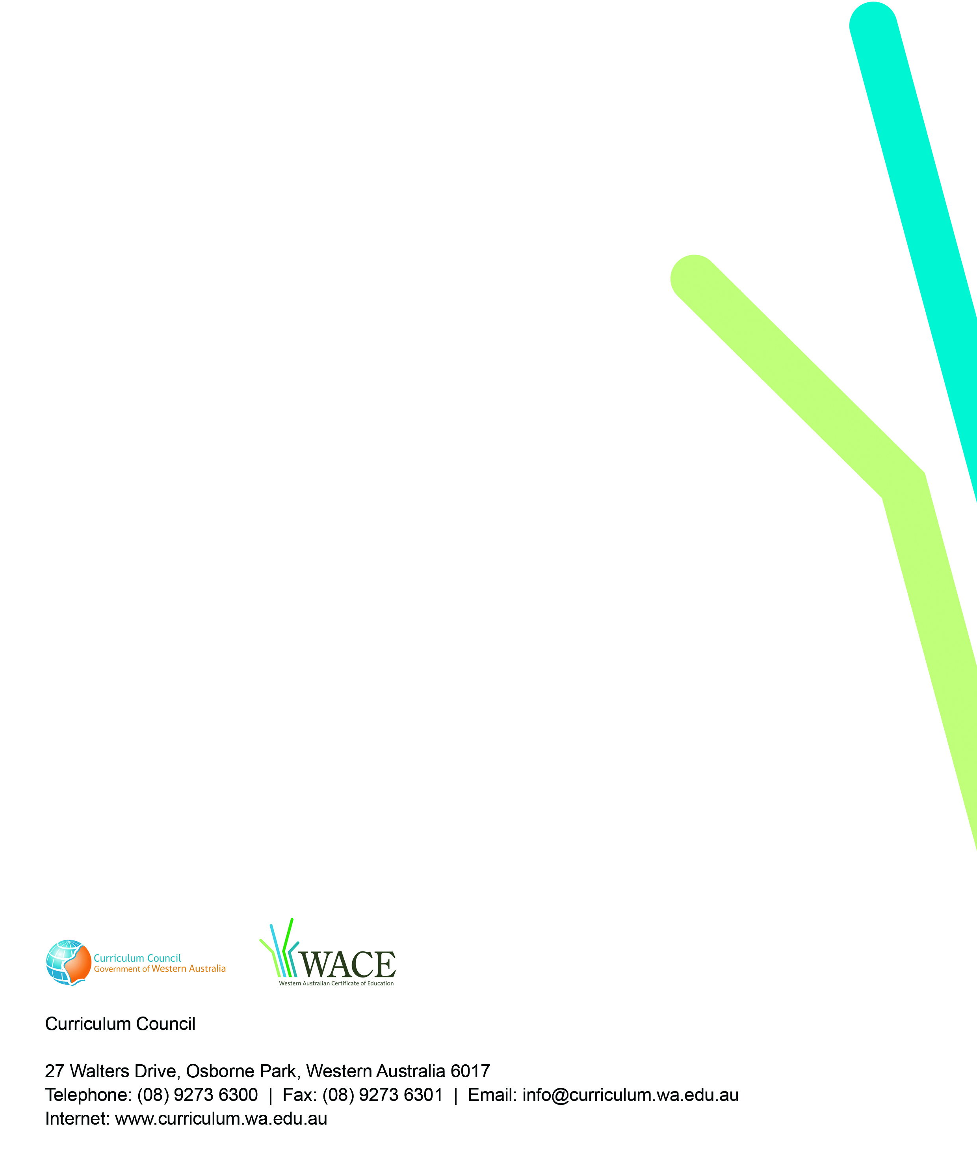
TRIM 2009/8143[v4]

